Doctoral School in Medical Sciences

As a manuscript
UDC: [579,84+615.33.015.8](043.2)

ANTON Maria

BETA-LACTAM RESISTANCE OF GRAM-NEGATIVE BACILLI ISOLATED FROM CLINICAL BIOSUBSTRATES

313.02 – MICROBIOLOGY, MEDICAL VIROLOGY

Summary of the PhD thesis in Medical Sciences

Chișinău, 2025
The PhD thesis was developed at the Microbiology Laboratory, National Agency for Public Health, Republic of Moldova, and the Center for Genomic Epidemiology, Technical University of Denmark.
Scientific advisor
Burduniuc Olga,
Dr. habil. med. sci., Associate Research Professor _________________

Advisory Committee Members:
Bucova Victoria,
Dr. habil. med. sci., Research Professor _________________
Spinei Larisa,
Dr. habil. med. sci., Research Professor __________________
Bălan Greta,
Dr. habil. med. sci., University Professor __________________

The PhD thesis defense is scheduled for ____ (date and time) at “Nicolae Testemițanu” SUMPh, 165 Ștefan cel Mare și Sfânt Blvd., office ___, during the session of the Public Doctoral Thesis Defense Committee, as approved by the Scientific Council of the Consortium in its decision dated _________ (minutes no. __).

Members of the Public PhD Thesis Defense Committee:
Bacinschi Nicolae,
Dr. habil. med. sci., University Professor, Chairperson ……………… ________________
Burduniuc Olga,
Dr. habil. med. sci., Associate Research Professor, Scientific advisor _________________
Bălan Greta,
Dr. habil. med. sci., University Professor, reviewer _________________
Ferdohleb Alexandru,
Dr. habil. med. sci., University Professor, reviewer _________________
Lozan-Tîrșu Carolina,
Dr. med. sci., University Professor, reviewer _________________

Author
Anton Maria ________________
©Anton Maria, 2025
CONTENTS
INTRODUCTION ……………………………………….......................................................... | 5
1. THE EVOLUTION OF ANTIMICROBIAL RESISTANCE IN GRAM-NEGATIVE BACTERIA …………………………………………………………………………………. | 16
2. STUDY MATERIALS AND METHODS ………………….............................................. | 38
3. DISTRIBUTION OF GRAM-NEGATIVE BACILLI AND THEIR ANTIMICROBIAL RESISTANCE PROFILES …………………………………………. | 49
3.1. Diversity and prevalence of Gram-negative bacilli species isolated from clinical biosubstrates ……………………………………….......................…………...………………. | 49
3.2. Antimicrobial resistance profiles of the isolates studied ………………….……………… | 50
3.3. Sensitivity and specificity of tests used to detect antimicrobial resistance mechanisms ...… | 69
4. GENOTYPES AND PHYLOGENETIC GROUPS OF MULTIDRUG-RESISTANT GRAM-NEGATIVE BACILLI ...........................................................................…………... | 74
4.1. Diversity of resistance genes and MLST profiles of antimicrobial-resistant gram-negative bacilli ....................................................................……………………………………………. | 74
4.2. Development of a standardized algorithm for detecting antimicrobial resistance mechanisms……………………………………………............................................................. | 84
GENERAL CONCLUSIONS ................................................................................................. | 92
RECOMMENDATIONS …………..…………………………............................................... | 93
SELECTIVE BIBLIOGRAPHY ............……………………………………………………. | 94
LIST OF PUBLICATIONS AND CONTRIBUTIONS TO SCIENTIFIC FORUMS ................ | 166

INTRODUCTION
Relevance of the research
Antimicrobial resistance (AMR) has emerged as one of the most critical global public health threats of the 21st century. Beyond its devastating impact on health, AMR places a significant social and economic burden on healthcare systems, driving up medical costs and contributing to treatment failures, which can sometimes be fatal [1,2,3,4,5].
In this context, Gram-negative bacilli are of particular concern due to their significant ability to rapidly develop and spread multiple resistance mechanisms [6]. The situation is especially alarming in infections caused by multidrug-resistant (MDR), extensively drug-resistant (XDR), and pandrug-resistant (PDR) bacteria, for which therapeutic options are extremely limited or, in some cases, completely unavailable [7.8]. Their high capacity to adapt to antibiotic pressure makes these pathogens a major challenge in medical practice, particularly in the context of healthcare-associated infections [6,9,10].
The relevance of this topic is strongly supported by recent reports from the World Health Organization (WHO), the Centers for Disease Control and Prevention (CDC) [11,12,13], and the European Centre for Disease Prevention and Control (ECDC) [14,15]. These reports classify carbapenem- and third-generation cephalosporin-resistant Gram-negative bacilli — including Klebsiella pneumoniae, Escherichia coli, Acinetobacter baumannii, and Pseudomonas aeruginosa — as a critical priority for the development of new antibiotics. Furthermore, they highlight that 10 out of the 18 major health threats associated with antibiotic-resistant microorganisms are caused by Gram-negative bacilli [16,17,18].
Non-fermenting Gram-negative bacilli are among the main causes of invasive infections, accounting for up to 75% of cases, including both healthcare-associated and community-acquired infections. Alarmingly, these pathogens are also responsible for up to 42% of infection-related deaths [6,11].
In the Republic of Moldova, as in many other resource-limited countries, the problem is further worsened by the irrational and excessive use of antimicrobial agents, the lack of comprehensive antimicrobial stewardship programmes, and insufficient microbiological surveillance capacity [19]. Local studies reveal a worrying trend of increasing prevalence of extended-spectrum β-lactamase (ESBL)-producing Enterobacterales and carbapenem-resistant strains. Among the priority pathogens identified are carbapenemase-producing Klebsiella pneumoniae (KPC), metallo-β-lactamase (MBL) and oxacillinase (OXA) producers, Pseudomonas aeruginosa, Acinetobacter baumannii, and third-generation cephalosporin-resistant Gram-negative bacilli, including ESBL-producing Escherichia coli [19,20,21].
At present, the capacity of microbiology laboratories in the country to detect ESBLs and carbapenemases remains limited. This is largely due to the wide variety of these enzymes and the absence of a clearly defined diagnostic algorithm. As a result, some mechanisms contributing to the development of AMR cannot be fully identified, increasing the risk of underdiagnosis [21,22,23].
This situation turns AMR from a theoretical threat into a pressing clinical and epidemiological reality. Patients with infections caused by resistant Gram-negative bacilli undergo longer hospital stays, require more expensive treatments, and experience significantly higher mortality rates. At the same time, healthcare systems come under growing pressure, and the risk of returning to a so-called “post-antibiotic era,” where common infections may once again become life-threatening, is becoming increasingly real [16,24,25].
Therefore, an in-depth investigation of antimicrobial resistance in Gram-negative bacilli is highly relevant today, highlighting the need to develop a standardized algorithm for detecting resistance mechanisms, as well as effective national policies for surveillance, prevention, and control. These measures should be aligned with the principles of the “One Health” approach and international recommendations.
High-quality research, data, and analysis are essential for developing new measures to combat AMR and for supporting policymakers in improving actions in this area.
The research purpose was to assess resistance profiles to β-lactams and determine the phylogenetic groups of priority GNB, with the development of a standardized methodological algorithm for detecting resistance mechanisms, and to propose effective measures for the prevention and control of antimicrobial resistance.
Research objectives are as following: to determine the antimicrobial resistance profiles of GNB isolated from various clinical biosubstrates; to perform molecular description of extended-spectrum beta-lactamases (ESBLs) and carbapenemases associated with GNB; to conduct a comparative analysis of different microbiological techniques for identifying beta-lactam-resistant GNB, with the development of a standardized methodological algorithm; and to propose effective measures for the prevention and control of infections caused by multidrug-resistant GNB.
Research hypothesis. The microbiological and epidemiological characteristics of antimicrobial resistance in GNB, shaped by the variability of resistance mechanisms and the effectiveness of surveillance and control strategies, play a main role in reducing the socioeconomic burden of infections caused by resistant bacteria and in strengthening efforts to combat AMR.
Scientific novelty and originality of the results. In the Republic of Moldova, a comprehensive study of priority Gram-negative bacteria was conducted using contemporary phenotypic methods and molecular biology techniques, which enabled the identification and characterization of resistance patterns and the detection of the main resistance mechanisms of these pathogens, as well as the assessment of the position of these Gram-negative bacteria within global phylogenetic trees. These data are extremely important for forecasting the evolution of resistance of these organisms at the regional level.
The study results served as the basis for developing a standardized algorithm for detecting antimicrobial resistance mechanisms, which will be implemented in microbiology laboratories within the national AMR surveillance network.
Findings that contributed to solving the scientific problem. This study identified the microbiological range of priority GNB, as well as the genotypic and phenotypic diversity of antimicrobial-resistant strains, including: the prevalence of ESBL- and carbapenemase-producing GNB strains in Moldova; the range of resistance enzymes in GNB; the predominant sequence type among circulating GNB strains in the country. A standardized algorithm for detecting antimicrobial resistance markers was developed, along with evidence-based recommendations for improving AMR surveillance and control.
Practical implementation of the results. Based on the research findings, a standardized algorithm for detecting antimicrobial resistance mechanisms in priority GNB was developed and scientifically justified.
To improve the quality of microbiological investigations, two practical guides were developed for medical personnel involved in the collection, transport, and processing of blood, cerebrospinal fluid (CSF), and urine samples for bacteriological testing.
Within the study, the guide “Detection of Antimicrobial Resistance Mechanisms, Interpretation and Clinical Application of the Results” was developed and approved by Order No. 1239 of 29.12.2023, as well as the methodological instruction “Detection of Antimicrobial Resistance Mechanisms”, approved at the meeting of the Quality Management Council of ‘Nicolae Testemițanu’ State University of Medicine and Pharmacy, minutes No. 2 of 29.11.2023. These educational materials were incorporated into the study programs for lectures and practical sessions for students, residents, and physicians, and were implemented in practice in the laboratories of public health centers.
The brochure “Method for raising awareness in children about the prevention of antimicrobial resistance”, developed during the study, is a valuable resource for introducing children to the world of microorganisms — both friendly and harmful — as well as to protective measures aimed at preventing infections caused by pathogenic microbes (Annex 7). This work was presented at the International Exhibition of Innovation and Technology Transfer EXCELLENT IDEA – 2023, 2nd Edition, Chișinău, under the title “Method for Raising the Degree of Awareness in Children About the Prevention of Antimicrobial Resistance”, where it was awarded a silver medal.
The leaflets, posters, and interactive games developed based on this brochure were presented at the event “European Researchers' Night”.
Research results approval. The research methodology and study design were reviewed and approved during the meeting of the Research Ethics Committee of Nicolae Testemițanu USMF, with a favourable opinion issued for the doctoral research project titled “Beta-lactam Resistance in Gram-Negative Bacilli Isolated from Clinical Biosubstrates”, meeting minutes No. 1 of January 10, 2022.
The thesis topic was discussed and approved within the primary unit at the joint meeting of the doctoral leadership, the members of the supervisory committee, and the staff of the Scientific Laboratory for Antimicrobial Resistance Surveillance, the Microbiology Laboratory, and the Department of Epidemiological Surveillance of Healthcare-Associated Infections and Antimicrobial Resistance (excerpt from the minutes No. 1 of the joint meeting of 11.02.2022), as well as at the specialized Scientific Seminar 313: Immunology, Microbiology, Virology, specialties 321.09 Infectious, Tropical and Parasitic Diseases, and 313.02 Medical Microbiology, Medical Virology (excerpt from the minutes No. 1 of 27.01.2023)
The PhD thesis results. The research findings are summarised in 28 scientific publications, including four as first author and two as sole author. These comprise: four articles published in SCOPUS-indexed journals, six articles in national scientific journals, one article in an international journal, two abstracts presented at international scientific forums, eight abstracts at national forums, one guide, one methodological guideline, and one educational brochure. The results were also shared through eight active presentations at scientific events. As part of this work, four innovation certificates were obtained.
PhD thesis volume and structure. The thesis is presented across 65 pages of core text and includes the following sections: title page, table of contents, lists of abbreviations, tables, and figures, introduction, four chapters, general conclusions, recommendations, 165 bibliographic references, and ninet annexes. The visual material comprises 14 tables and 31 figures.
Keywords: antimicrobial resistance, MDR Gram-negative bacilli, resistance mechanisms, extended-spectrum β-lactamases, carbapenemases.

PHD THESIS CONTENT
1. THE EVOLUTION OF ANTIMICROBIAL RESISTANCE IN GRAM-NEGATIVE BACTERIA
This chapter presents a comprehensive overview of the most relevant findings from the scientific literature over the past decade concerning the evolution of antimicrobial resistance in GNB. It describes the theoretical foundations underlying the development of major resistance mechanisms commonly found in GNB worldwide, alongside national and international research efforts in the field of microbiological diagnosis of AMR and the epidemiological trends associated with this phenomenon. The chapter also highlights the critical role of GNB in infectious diseases and emphasises the clinical significance of these pathogens. Particular attention is given to the main resistance mechanisms identified in GNB, as well as to modern laboratory techniques used for their detection, outlining both their strengths and limitations. The chapter concludes by presenting the rationale that led to the initiation of this research.

2. STUDY MATERIALS AND METHODS
A comprehensive study was carried out on GNB strains collected between 2020 and 2023. The research was conducted at the Microbiology Laboratory of the National Agency for Public Health, in collaboration with the Genomic Epidemiology Centre of the Technical University of Denmark. Laboratory investigations were performed in vitro on suspected GNB strains submitted to the National Reference Laboratory for confirmation of resistance mechanisms. These strains were referred by all laboratories within the National AMR Epidemiological Surveillance System, which includes 24 laboratories — ten regional laboratories of the National Agency for Public Health, ten laboratories from public healthcare institutions, and four private laboratories.
The study material included GNB strains isolated from blood, cerebrospinal fluid (CSF), and urine samples.
To meet the research objectives and fulfil the overall purpose of the study, investigations were conducted in several stages, as described below.
The first stage of the study involved a comprehensive review of 480 scientific sources on AMR in GNB, using electronic databases such as MEDLINE, PubMed, HINARI, and other online platforms. The most relevant publications from the past ten years, directly related to the research topic, were selected and listed in the Bibliography. Particular attention was given to national sources addressing methods for detecting resistance mechanisms and the current epidemiological situation of AMR in the country.
In the second stage, the study material was defined, and strains resistant to at least one beta-lactam antibiotic were selected. At this stage, the most appropriate methodology for achieving the research objectives was chosen, and microbiological investigations were carried out. A dedicated database was created, followed by statistical processing and analysis of the collected data. The calculated statistical indicators were interpreted, and the results were compared with similar international studies. The study concluded with five key findings, demonstrating that the research objectives and overall purpose had been fully achieved. Based on these results, a set of recommendations was proposed to help tackle the AMR phenomenon.
In the third stage, the research findings were shared through multiple means, including publications within national and international scientific journals, abstracts, and active participation with presentations or posters at both national and international scientific events. The results also led to the development of a practical guide, a methodological handbook, and an educational brochure.
2.2. Research methods
The study of beta-lactam-resistant GNB was carried out as a comprehensive investigation. To achieve its objectives, a combination of the following methods was used, namely descriptive and analytical methods, applied to synthesise and summarise data from the scientific literature; analytical methods, used to assess and compare different techniques for detecting resistance mechanisms; microbiological methods, employed to identify resistance mechanisms in the studied strains; epidemiological methods, used to determine the prevalence of phylogenetic groups of GNB and the types of resistance enzymes found in these pathogens; statistical methods, used in processing, analysing, and interpreting the research data.
Microbiological Method
Polymerase chain reaction. Genotypic confirmation of resistance mechanisms was carried out using PCR. The procedure includes three main steps: extraction of bacterial DNA, amplification, and detection. Specific primers targeting the OXA-48, KPC, VIM, IMP, and NDM genes were used to identify beta-lactamase and carbapenemase producers.
The PCR mixture for detecting genes encoding ESBL and carbapenemase production contained: 25 μl of 10X buffer (with 15 mM MgCl₂), 0.5 U of Taq DNA polymerase (Roche), 200 μM of each deoxynucleotide triphosphate, 5 μmol of each primer, and 50–100 ng of extracted DNA. This method allowed for reliable detection of the enzymes responsible for antimicrobial resistance in these microorganisms [30].
Whole-genome sequencing is a state-of-the-art method that enabled the identification of resistance genes, as well as the detection of genetic variability and mutations within the genomes of antimicrobial-resistant GNB.
Nucleic acid (DNA) was extracted from the bacterial suspension using the DNeasy Blood and Tissue Kit (Qiagen, Germany), following the manufacturer’s standard protocol. Genomic DNA extraction was performed via silica membrane spin-column technology, which ensures high-purity DNA isolation.
In the first step of the extraction process, samples were lysed with lysis buffer and proteinase K. The resulting lysate was then transferred to a spin column. During centrifugation, the DNA bound to the silica membrane, while contaminants and enzyme inhibitors were removed through two wash steps. Finally, the purified DNA was eluted using an elution buffer, resulting in high-quality DNA ready for downstream applications.
The extracted DNA was then sequenced using Illumina whole-genome paired-end sequencing technology (2 × 150 bp reads). DNA libraries were prepared with the Nextera XT kit (Illumina, San Diego, CA, USA), using 1 ng of genomic DNA per sample.
During this process, the genomic DNA was fragmented and tagged with adapter sequences (indexing). The tagged DNA was then amplified by PCR and purified using AMPure XP beads. To quantify the prepared libraries, 2 µl of each DNA sample was mixed with 198 µl of working solution, and the DNA concentration was measured using a Qubit 4 fluorometer.
The sequencing libraries were then normalised to a concentration of 1 nM and pooled into a single tube. The combined library was diluted, denatured, and prepared for sequencing using the NextSeq platform with the NextSeq 500/550 v2.5 kit (300 cycles).
The bioinformatic analysis of the bacterial genome sequencing results was carried out using the services of the Center for Genomic Epidemiology (https://www.genomicepidemiology.org/services/). To interpret the sequencing data and identify antimicrobial resistance genes along with their specific locations in the bacterial genome, the ResFinder tool (version 4.6.0) was used (https://genepi.food.dtu.dk/resfinder). Plasmid detection was performed using PlasmidFinder (version 2.1) (https://cge.food.dtu.dk/services/PlasmidFinder/). Multilocus Sequence Typing (MLST) for each isolate was determined using the MLST tool (version 2.0) (https://cge.food.dtu.dk/services/MLST/). Phylogenetic trees were generated from the sequencing data using CSI Phylogeny (version 1.4) (https://cge.food.dtu.dk/services/CSIPhylogeny/). The reference genomes used for comparison included K. pneumoniae ST395, E. coli ST131, P. aeruginosa ST235, and A. baumannii ST2063. The data files were visualised and processed using the interactive online tool iTOL (https://itol.embl.de/). To identify hypervirulent strains, the Kleborate tool from PathogenWatch was used (https://pathogen.watch/).
2.3. Mathematical and statistical data processing
The data were processed automatically using open-source software — RStudio (version 2024.09.1+394, https://www.rstudio.com/) and Python (version 3.12.3, https://www.python.org/). These modern tools, widely recognised by the academic and research community, ensured a rigorous, efficient, and fully reproducible analysis of the dataset. Their use was essential for maintaining transparency throughout the analytical process, ensuring the validity of the results, and allowing for independent replication. The source codes used for data processing and analysis are available upon request, making it possible to verify the results and apply the methodology in similar future studies.
For categorical variables, absolute and relative frequencies were calculated, accompanied by 95% confidence intervals for estimating proportions. This approach provided a reliable statistical description of how the data were distributed within each category. The results were visually presented using bar charts and back-to-back bar charts, allowing for a clear and easy comparison of category distributions and differences between groups.
To assess the hypotheses related to categorical variables, Pearson’s Chi-square test was used. Regardless of sample size or frequency distribution, the Monte Carlo simulation method was applied, generating 100,000 random samples to obtain a reliable estimate of the p-value. This approach was chosen to ensure the validity of statistical testing, even in cases of small sample sizes or imbalanced categories.
All statistical analyses were performed using a standard significance level (α) of 0.05. Results were interpreted accordingly: p-values below 0.05 were considered statistically significant. In addition to statistical significance, the practical relevance and clinical importance of the observed differences were carefully considered, taking into account the specific context of the study, the magnitude of the effects, and their potential impact on public health decisions and clinical practice.

3. DISTRIBUTION OF GRAM-NEGATIVE BACILLI AND THEIR ANTIMICROBIAL RESISTANCE PROFILES
3.1. Diversity and prevalence of GNB species isolated from clinical biosubstrates
An analysis of the diversity of GNB species isolated from clinical samples collected by laboratories within the Antimicrobial Resistance Surveillance System between 2020 and 2023 revealed that K. pneumoniae was the most commonly isolated species, accounting for 47.1% (95% CI: 45.2–49.5) of cases. This was followed by E. coli at 42.9% (95% CI: 41.0–45.3), A. baumannii at 7.4% (95% CI: 5.3–9.6), and P. aeruginosa, which was found in 2.7% (95% CI: 0.1–4.4) of infection cases.
For E. coli and K. pneumoniae, the highest isolation rates came from the intensive care unit, accounting for 41.3% (95% CI, 39.5–43.1) of strains. This was followed by internal medicine wards at 18.2% (95% CI, 16.8–19.6), urology at 13.4% (95% CI, 12.1–14.7), and surgery at 6.3% (95% CI, 5.4–7.2).
P. aeruginosa and A. baumannii strains were predominantly isolated from ICU patients, making up 76.5% (95% CI, 67.3–85.8) of samples, with smaller proportions found in the pediatric ICU at 9.9% (95% CI, 3.4–16.4) and surgery at 6.2% (95% CI, 0.9–11.4).
3.2. Antimicrobial resistance profiles of the isolates studied
Analysis of the E. coli strains revealed that out of 1,306 tested isolates, 57.0% (95% CI, 48.3–66.5) were resistant to penicillins, 61.8% (95% CI, 49.3–68.5) to cephalosporins, and only 2.1% (95% CI, 0.1–4.5) to carbapenems. Resistance was also found in 72.1% (95% CI, 64.3–81.5) of strains against fluoroquinolones, 32.2% (95% CI, 24.8–40.2) against aminoglycosides, and 3.0% (95% CI, 1.3–5.1) against colistin.
Among the multidrug-resistant strains, 42.1% (95% CI, 36.3–49.7) of E. coli showed resistance to three or more classes of antimicrobials. Notably, 1.4% (95% CI, 0.2–2.1) exhibited extensive resistance, being resistant to all tested antibiotics except colistin, and 0.3% (95% CI, 0.0–1.9) were pan-resistant, showing resistance to every antibiotic tested.
The majority of K. pneumoniae strains—93.9% (95% CI, 85.3–98.9)—were resistant to cephalosporins and fluoroquinolones; 81.5% (95% CI, 76.1–89.6) to aminoglycosides; 51.1% (95% CI, 43.8–58.6) to carbapenems; and 15.0% (95% CI, 8.7–23.4) to colistin (figure 1).
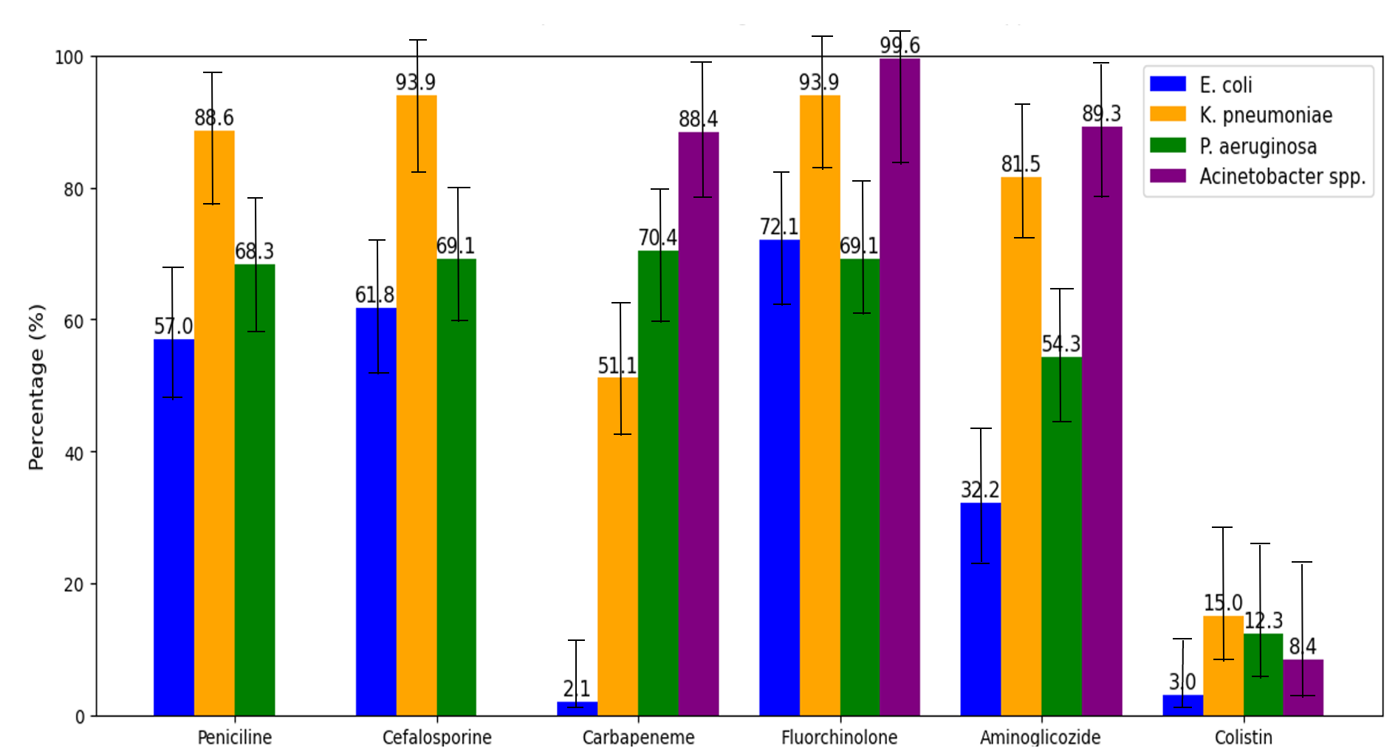
Figure 1. Resistance of studied GNB Species to selected antimicrobial groups
More than 70.0% (95% CI, 63.4–76.9) of K. pneumoniae strains were multidrug-resistant (MDR), exhibiting combined resistance to penicillins, cephalosporins, aminoglycosides, and fluoroquinolones. Extensively drug-resistant (XDR) strains made up 47.0% (95% CI, 40.3–55.6) of the K. pneumoniae isolates, while pan-drug-resistant (PDR) strains—resistant to all tested antimicrobials—were found in 13.7% (95% CI, 6.2–20.3) of these isolates.
P. aeruginosa showed resistance rates of 70.4% (95% CI, 63.8–77.6) to carbapenems, 69.1% (95% CI, 61.3–75.4) to cephalosporins, the same percentage to fluoroquinolones, 68.3% (95% CI, 58.3–76.5) to penicillins, 54.3% (95% CI, 46.4–62.2) to aminoglycosides, and 12.3% (95% CI, 8.7–18.1) to colistin.
Among P. aeruginosa isolates, 66.7% (95% CI, 58.8–76.5) were MDR, 49.4% (95% CI, 38.3–56.5) were XDR, and 12.3% (95% CI, 8.8–16.3) were PDR.
A. baumannii is becoming increasingly resistant to multiple groups of antimicrobials, leaving almost no effective treatment options for the severe infections it usually causes. In this study, 99.6% (95% CI, 95.4–100) of the A. baumannii strains were resistant to fluoroquinolones, 89.3% (95% CI, 83.6–92.3) to aminoglycosides, and 88.4% (95% CI, 84.7–96.5) showed resistance to last-resort antibiotics. In our study, 8.4% (95% CI, 2.3–12.8) of isolates were resistant to colistin. Nearly all strains were multidrug-resistant (99.1%, 95% CI, 98.8–99.9), with 8.4% (95% CI, 1.5–14.6) classified as pan-resistant.
Analysis of resistance mechanisms found in GNB by various methods
TSA was used as a screening method to identify the production of extended-spectrum beta-lactamases (ESBLs) and carbapenemases. Antibiogram analysis helped find strains suspected of producing resistance enzymes. During this process, some strains were found to have developed two or more resistance mechanisms simultaneously.
Using the DDST method, resistance to penicillins was confirmed in only 2.7% (95% CI, 1.5–3.8) of the E. coli isolates suspected of producing AmpC β-lactamase. Of the 1,271 K. pneumoniae strains resistant to penicillins and suspected of AmpC production, only 2.2% (95% CI, 1.4–3.0) were confirmed by DDST.
Isolates resistant to cephalosporins and suspected of ESBL production were tested using three phenotypic methods. With the cultural method, 90.1% (95% CI, 88.0–92.0) of the E. coli isolates formed pink or violet colonies on chromogenic medium, thus confirming ESBL production. Among cephalosporin-resistant K. pneumoniae colonies, 45.1% (95% CI, 39.0–44.0) proved to be ESBL producers, forming blue colonies on this medium.
DDST confirmed that 90.0% (95% CI, 88.0–92.0) of E. coli strains resistant to cephalosporins and 36.6% (95% CI, 34.0–39.0) of K. pneumoniae strains resistant to cephalosporins are ESBL producers
The confirmation of carbapenemase-producing strains was performed using the PCR method. In E. coli, the dominant carbapenemase gene was oxa-48, detected in 34.9% (95% CI, 29.5–38.8) of isolates suspected of producing carbapenemases. This was followed by blaNDM at 23.3% (95% CI, 20.4–26.5), blaKPC at 14.0% (95% CI, 10.6–17.0), blaVIM at 12.8% (95% CI, 8.3–15.7), and blaIMP at 10.5% (95% CI, 5.8–13.2) among the suspected carbapenemase-producing strains.
In K. pneumoniae, OXA-48 was also the most commonly detected enzyme, present in 64.8% (95% CI, 61.1–66.5) of carbapenemase-suspected isolates. This was followed by NDM at 44.0% (95% CI, 39.9–49.5), KPC at 15.4% (95% CI, 10.3–19.4), IMP at 2.6% (95% CI, 0.8–4.5), and VIM at 2.5% (95% CI, 0.6–5.7).
The prevalence of resistance genes in P. aeruginosa isolates differed from that seen in E. coli and K. pneumoniae. The blaNDM gene was the most common, found in 42.0% of suspected carbapenemase-producing strains (95% CI, 38.3–48.4), followed by blaOXA-48 at 37.0% (95% CI, 32.5–41.6), blaKPC at 23.5% (95% CI, 18.1–26.2), and blaVIM at 16.0% (95% CI, 11.3–21.6). The blaIMP gene was not detected in any of the P. aeruginosa strains tested by PCR (figure 2).
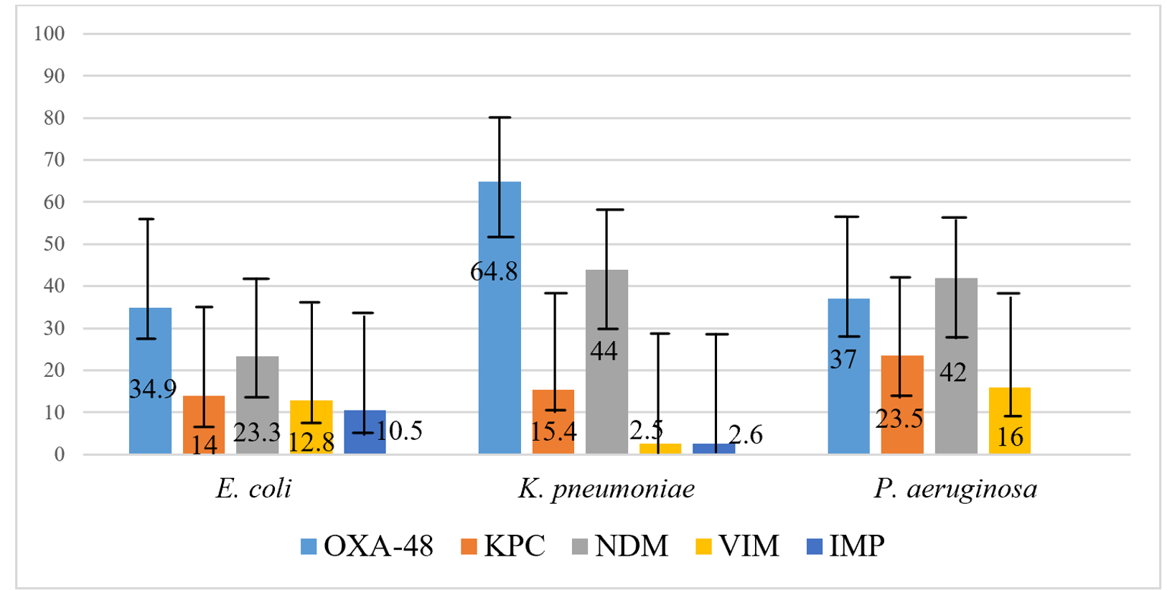
Figure 2. Spectrum of resistance enzymes found by PCR in isolates of E. coli, K. pneumoniae, and P. aeruginosa
A. baumannii shows a unique resistance enzyme profile compared to the other species studied. Among the resistance genes identified in the A. baumannii strains were blaOXA-23, blaOXA-40, and blaOXA-58. Out of 214 isolates suspected of producing carbapenemases, 84.6% (95% CI, 82.7–86.5) were confirmed. The most common carbapenemase was OXA-23, found in 43.5% (95% CI, 38.9–46.5) of the suspected strains, followed closely by OXA-40 producers at 41.1% (95% CI, 37.8–44.9), and OXA-58 producers at 7.5% (95% CI, 5.4–9.6).
3.3. Sensitivity and specificity of tests used to detect antimicrobial resistance mechanisms
The tests used to identify antimicrobial resistance mechanisms in GNB included in this study were evaluated based on their sensitivity and specificity.
To detect ESBL production in E. coli and K. pneumoniae, phenotypic methods such as DDST, combined disc tests, CHROMagar™ ESBL chromogenic media, and the E-Test were employed. The performance of these ESBL detection methods was assessed using the E-Test as the gold standard, due to its higher sensitivity, reliability, and suitability.
Among the three phenotypic tests, the combined disc test showed the highest sensitivity and specificity. However, when comparing the combined disc test to the other methods in terms of overall accuracy, no statistically significant difference was observed (p = 0.207).
For carbapenemase detection, the immunochromatographic test demonstrated the highest sensitivity and specificity among the phenotypic tests. It showed a sensitivity of 86.2% (95% CI: 84.0–88.2) and a specificity of 91.7% (95% CI: 88.7–93.9), significantly outperforming both the CarbaNP test (p < 0.001) and the MAST CarbaPACE test (p < 0.001).
The detailed performance results of the immunochromatographic test in identifying specific resistance enzymes are presented in Table 1.
The immunochromatographic test detected 82.1% (95% CI, 80.0–85.5) of OXA-48-producing strains, 91.4% (95% CI, 83.9–95.6) of OXA-23, 36.4% (95% CI, 29.8–43.5) of KPC, 55.9% (95% CI, 51.7–60.2) of NDM, 41.7% (95% CI, 28.8–55.7) of VIM, and 8.6% (95% CI, 3.0–22.4) of IMP producers.

Table 1. Performance of the immunochromatographic test for identifying resistance enzyme types
Results | Positive / Total tested | TP | TN | FP | FN | Sensitivity (95% CI) | Specificity (95% CI)
OXA-48 | 593/722 | 593 | 457 | 85 | 122 | 82,1% (80,0-85,5) | 84,3% (81,0-87,1)
OXA-23 | 85/93 | 85 | 110 | 11 | 8 | 91,4% (83,9-95,6) | 90,0% (83,5-94,2)
KPC | 68/187 | 68 | 1041 | 18 | 119 | 36,4% (29,8-43,5) | 98,3% (97,3-98,9)
NDM | 279/499 | 279 | 733 | 29 | 220 | 55,9% (51,5-60,2) | 96,2% (94,6-97,3)
VIM | 20/48 | 20 | 1132 | 8 | 28 | 41,7% (28,8-55,7) | 99,3% (98,6-99,6)
IMP | 3/35 | 3 | 1124 | 26 | 32 | 8,6% (3,0-22,4) | 97,7% (96,7-98,5)
TP – true positives; TN – true negatives; FP – false positives; FN – false negatives; DDST – double-disc synergy test.
The test showed high sensitivity and specificity for detecting OXA-23 and OXA-48 enzymes. For the other enzymes, it demonstrated high specificity but lower sensitivity, struggling particularly with detecting KPC, VIM, and IMP producers. Moderate agreement was observed between this test and PCR results for NDM detection.

4. GENOTYPES AND PHYLOGENETIC GROUPS OF MULTIDRUG-RESISTANT GRAM-NEGATIVE BACILLI
4.1. Diversity of resistance genes and MLST profiles of antimicrobial-resistant gram-negative bacilli
The strains sequenced in this study were selected based on the ECDC Study Protocol for Genomic Surveillance of Carbapenem- and/or Colistin-Resistant Enterobacteriaceae in the EU, version 2.0p, 2018. The protocol specifies the collection of the first 10 consecutive, non-duplicate bacterial isolates from clinical samples obtained for diagnostic purposes (blood, CSF, urine, sputum, and wound secretions). For each set of 10 resistant isolates, one strain of the same species but susceptible to carbapenems was subsequently selected [26].
At the regional level, the strains were tested for antimicrobial resistance and then sent for confirmation to the National Reference Laboratory for AMR within the National Agency for Public Health. After confirming antimicrobial resistance and the corresponding resistance mechanisms, the strains, accompanied by metadata (clinical, epidemiological, and microbiological data), were sent to the Center for Genomic Epidemiology at the Technical University of Denmark for sequencing and analysis
Klebsiella pneumoniae
For the phylogenetic analysis of K. pneumoniae, 99 strains isolated from blood and CSF were examined.
Using bioinformatics tools, the phylogenetic analysis revealed that all strains belonged to 16 different sequence types (STs) and shared familiar allelic profiles listed in the Center for Genomic Epidemiology’s MLST database.
Bioinformatic analysis showed that sequence type ST395 was the most common, found in 56 K. pneumoniae strains, followed by ST377 in 12 strains, ST23 in 5 strains, ST11 in 4 strains, and ST1026 in 4 strains. Additionally, unique isolates with sequence types ST14, ST15, ST25, ST37, ST101, ST147, ST370, ST380, ST405, ST1037, and ST6381 were identified.
Importantly, the ST23 genes associated with the hypervirulence of K. pneumoniae strains isolated from blood were detected in five isolates. Beta-lactamases including CTX-M (blaCTX-M-55), OXA (blaOXA-1, blaOXA-48), TEM (blaTEM-1B), SHV (blaSHV-45), and LAP (blaLAP-2) were also found in these hypervirulent strains.
Using whole-genome sequencing data, a phylogenetic tree was constructed for K. pneumoniae ST395, the most common sequence type found in the country (Figure 3).
The analysis revealed genetic diversity among the studied K. pneumoniae ST395 strains, with several strains showing closely related nucleotide sequences.
The sequencing results also demonstrated epidemiological links between the isolates. All ST395 strains were grouped into two clusters: Cluster I included 32 isolates with similar genomic structures, while Cluster II comprised 23 isolates spread across several subclusters. One strain, isolated at the National Public Health Agency microbiology lab (ANSP-2023-103075i) and highlighted in green, did not belong to either cluster, indicating no epidemiological connection with the other isolates shown in Figure 9.
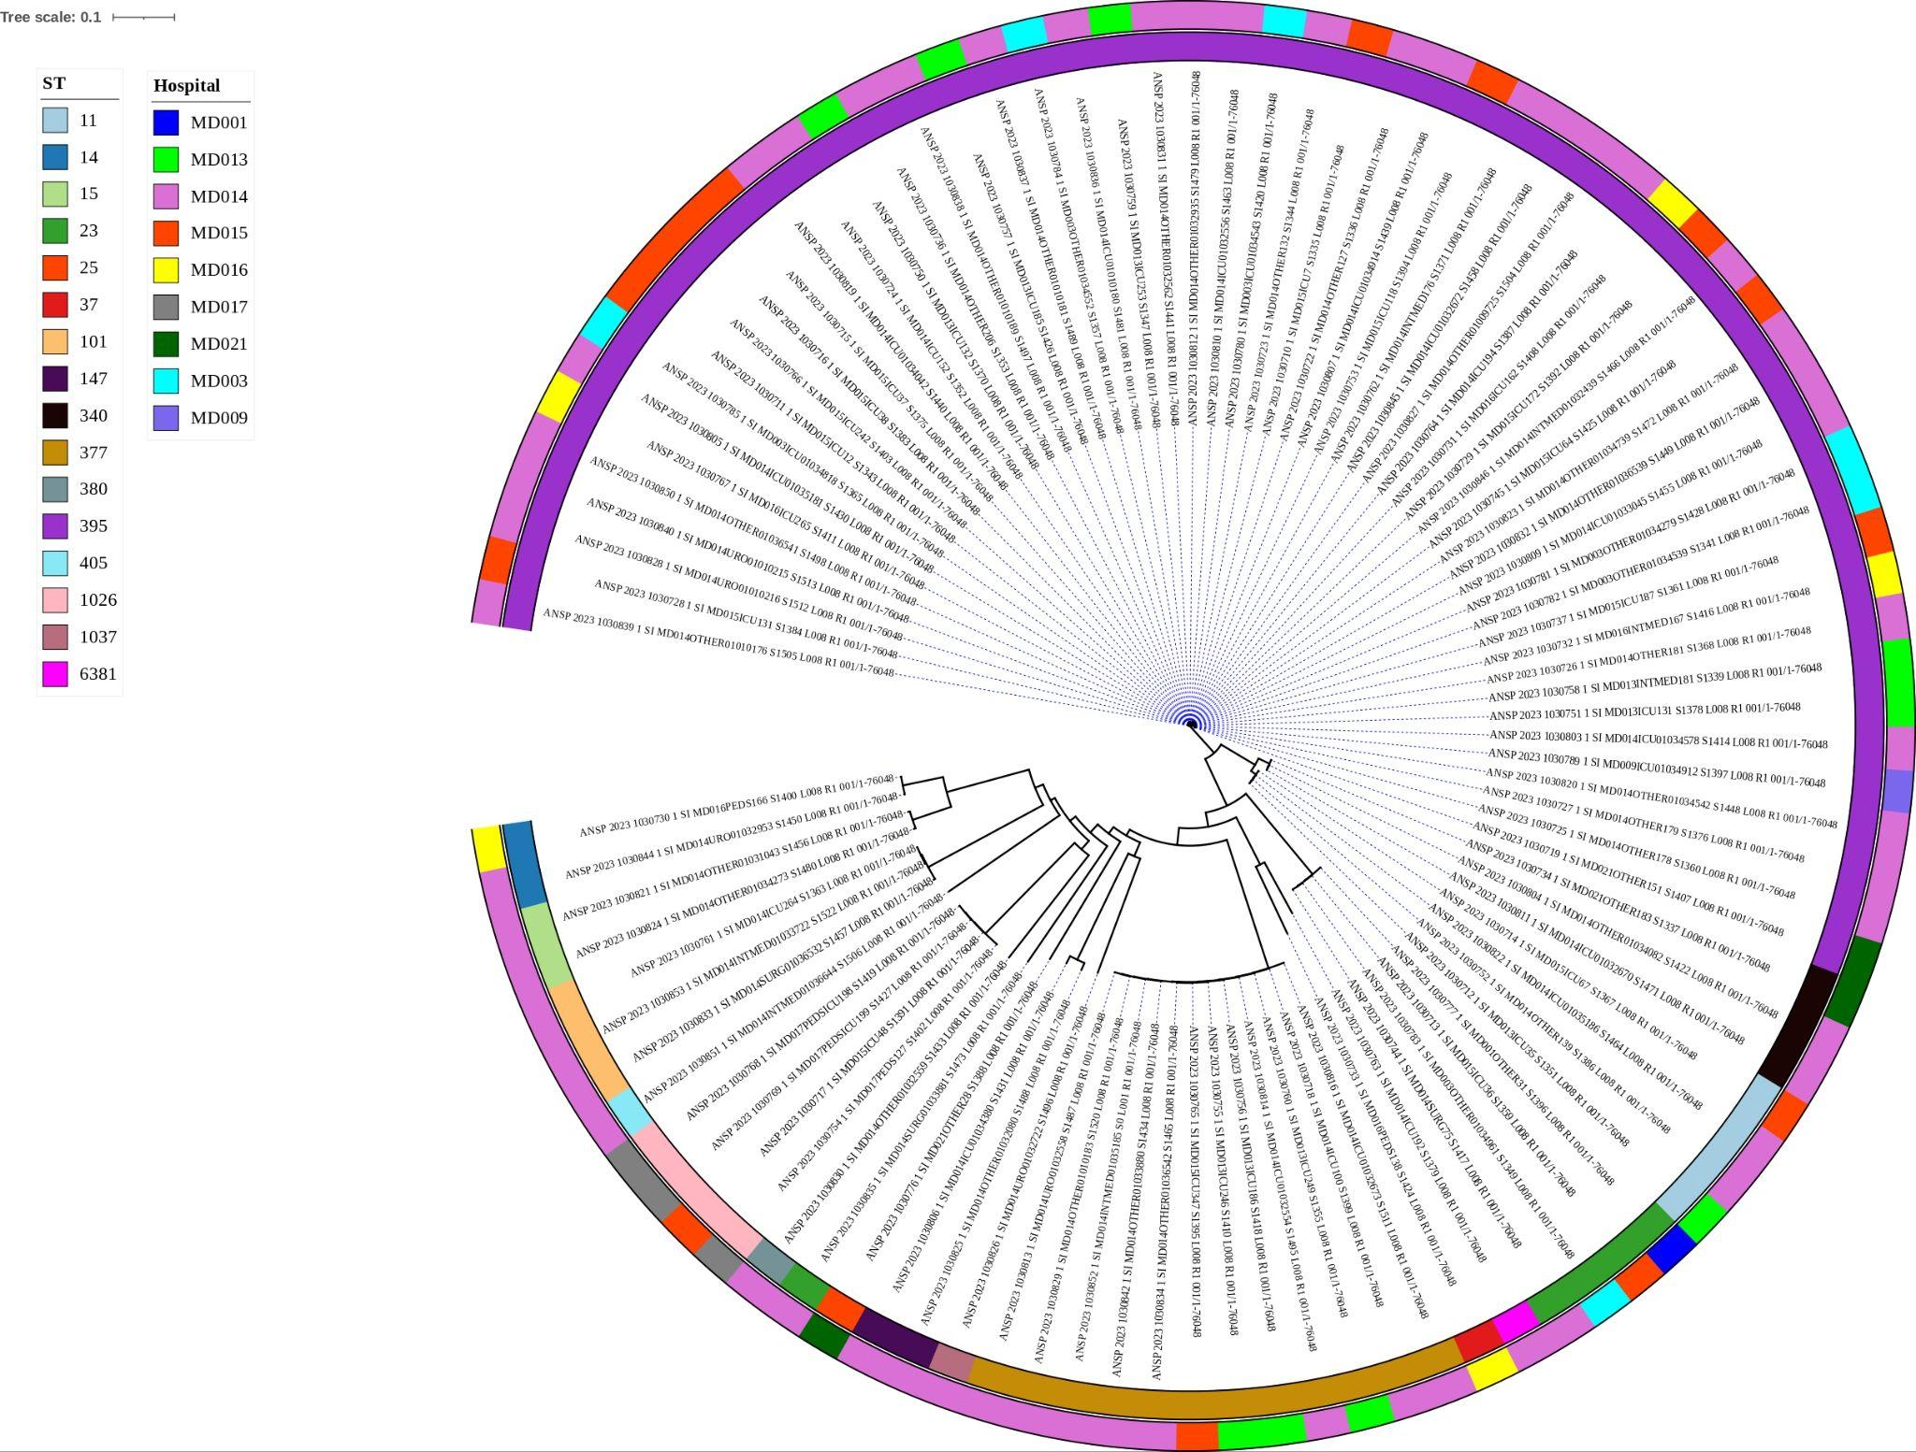
Figure 3. Phylogenetic analysis of K. pneumoniae ST395 (iTOL)
Tracking the appearance of isolates from Cluster I across hospitals in the country showed that the first invasive strains emerged in 2020 at the republican hospital MD015A, specifically in the intensive care unit (samples 1030710, 1030711, 1030715, 1030716). In the following year, ST395 spread further. Besides MD015A, strains from the same cluster were found at the tertiary-level hospital MD014A (samples 1030722, 1030723, 1030724, 1030736), both in the intensive care unit and other therapeutic departments.
In 2022, these isolates were detected in the intensive care units of two other secondary-level hospitals: MD013A (1030750, 1030759, 1030757) and MD016A (1030767).
By 2023, several strains from the first ST395 cluster had been isolated from blood and urine samples in municipal hospitals: at MD013A (blood isolates 1030839, 1030810, 1030812, 1030838, 1030837, 1030831, 1030836; urine isolate 1030805), MD016A ICU (blood isolates 1030828, 1030840; urine isolate 1030785), and the obstetrics and gynecology ward (urine isolate 1030850). At the national level, isolates were found in MD014A ICU (urine isolate 1030819), MD015A ICU (urine isolate 1030780), and an outpatient clinic at a district hospital in Râșcani (urine isolate 1030807).
The first invasive isolate from the second cluster of 23 K. pneumoniae ST395 strains was identified in 2021 at a tertiary hospital—MD021A (1030719). Additional invasive isolates were reported by MD014A (1030725, 1030726, 1030727), MD015A ICU (1030729, 1030737), MD016A ICU (1030731), and the internal medicine ward (1030732).
In 2022, strains from the second cluster were found in institution MD013A, specifically in the intensive care unit (1030751) and the internal medicine ward (1030758), as well as in the intensive care units of medical facilities MD014A (1030764) and MD015A (1030745).
By 2023, the number of isolates in this cluster had grown to 11. They were detected in MD013A’s intensive care unit (1030846, from blood) and urology ward (1030820, from urine); MD016A (1030832, from urine) in the internal medicine ward; MD014A (1030809, 1030827, from blood) in the intensive care unit; and MD015A in both the intensive care unit (1030845, from blood) and urology ward (1030845, from urine). Additionally, two urine isolates (1030789, 1030823) were found in outpatient clinics, indicating that this strain is spreading beyond hospital settings to other healthcare facilities across the country. An invasive K. pneumoniae ST395 strain, isolated in 2022 at the tertiary-level hospital MD014A in a therapeutic ward, was not assigned to any cluster.
Escherichia coli
Among the 19 sequenced E. coli isolates, nine different sequence types (STs) were identified, showing varied frequencies, predominance, and a high level of allelic diversity. This genetic diversity likely reflects the species’ extensive genetic variability and the ability of virulence and antibiotic resistance genes to be transferred horizontally within bacterial populations that colonize the human body.
All E. coli isolates were grouped into nine distinct STs based on MLST analysis of their genome sequences (Figure 4).
The most common and dominant sequence types (ST) among the E. coli isolates were ST131 (n = 9) and ST405 (n = 2). All other STs appeared in just one isolate each. ST131 was the most frequently found type in Moldova, accounting for 50% of all E. coli isolates analyzed, reflecting its genotypic dominance. This likely reflects the widespread endemic presence of this ST among strains isolated from hospitalized patients.

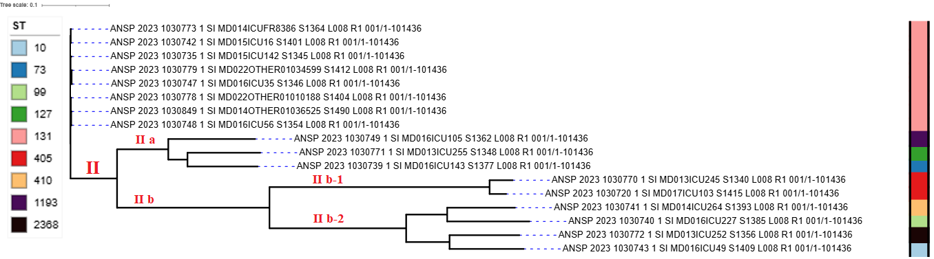
Figure 4. Phylogenetic tree of E. coli strains based on MLST-assembled nucleotide sequences (MLST, iTOL)
The phylogenetic analysis of the E. coli sequence types identified two main groups: Cluster I, which consists solely of E. coli ST131, and Cluster II, which includes all the other STs. Cluster II is further divided into two subgroups: Ia, containing three STs (ST1193, ST127, ST73), and Ib, which splits into two more subgroups—IIb-1 (ST405) and IIb-2 (ST410, ST99, ST2368, ST10).
Using the whole-genome sequencing data, a phylogenetic tree was built for Cluster I, focusing on E. coli ST131, the most prevalent sequence type found in the country (Figure 5).

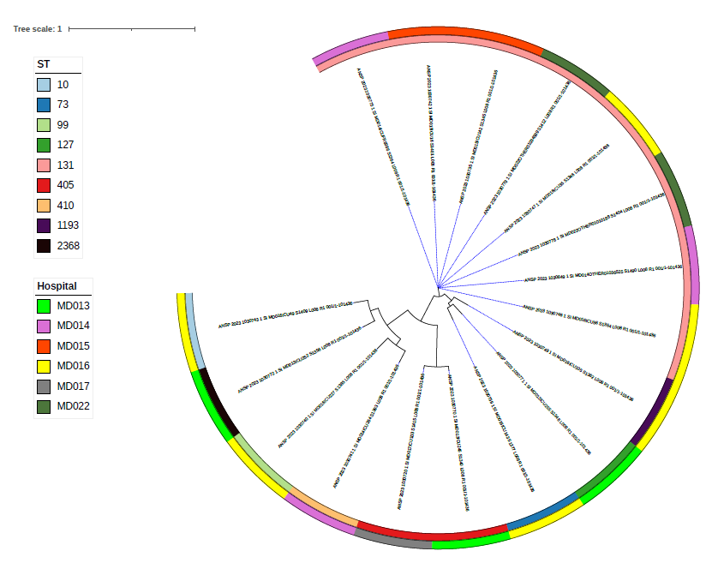
Figure 5. Phylogenetic analysis of E. coli isolates based on whole-genome multilocus sequence typing (MLST, iTOL)
The phylogenetic analysis of the E. coli isolates made it possible to track the spread of strains across medical institutions in the country. Thus, the first E. coli ST131 isolate was detected in 2021 in the ICU of IMSP MD014A; in 2022, two additional ST131 strains were isolated in another tertiary-level hospital (MD015A). In 2023, such isolates were identified in the intensive care units of three other medical institutions in the country: MD014A – 1 strain, MD022A – 2 strains, and MD016A – 2 strains.
The E. coli isolates were typed using whole-genome sequencing, with a focus on detecting resistance genes.
All isolates were analyzed for antimicrobial resistance using bioinformatic methods across the antibiotic classes studied: aminoglycosides, beta-lactams, macrolides, sulfonamides, tetracyclines, and trimethoprim (Figure 6). In the heatmap, red indicates the presence of resistance genes, while green indicates their absence.
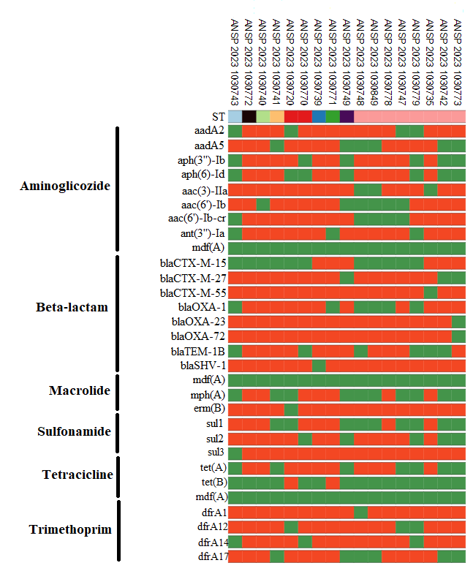
Figure 6. Typing of E. coli isolates and bioinformatic genome analysis (ResFinder, iTOL)
Analysis of the genome sequences revealed 30 acquired antimicrobial resistance genes spanning six different classes.
Within the CTX-M family, the blaCTX-M-15 gene was detected in six isolates, blaCTX-M-27 in 14 isolates, and blaCTX-M-55 was present in nearly all isolates (six in total).
The blaOXA-1 gene appeared in 11 E. coli genomes, while blaOXA-23 and blaOXA-72 were found in most of the sequenced isolates (16 samples), with only one isolate lacking these genes.
Among the β-lactamase genes, blaTEM-1B was identified in 11 isolates.
A total of nine aminoglycoside resistance genes were detected: aadA2 in 13 isolates; aadA5, aph(3″)-Ib, and aac(6′)-Ib each in 11 isolates; aac(6′)-Ib-cr in 12; aph(6)-Id in ten; and both aph(3′)-IIa and ant(3′)-Ia in 14 isolates each.
The macrolide resistance gene erm(B) was found in almost all analyzed genomes, while the mdf(A) gene was not detected in any isolate.
The sulfonamide resistance gene sul1 appeared in the genomes of eight E. coli strains, sul2 in twelve strains, and sul3 in 16 strains.
Among the four genes linked to trimethoprim resistance, dfrA1 was present in 16 isolates, dfrA12 and dfrA14 each in 14 isolates, and dfrA17 in 11 isolates (Figure 6).
Acinetobacter baumannii
Whole-genome sequencing of A. baumannii offers deeper insight into the evolutionary relationships within groups of isolates, their virulence potential, and antibiotic resistance profiles. Like the previously mentioned isolates, SNP-based genomic analysis of A. baumannii strains helps establish correlations between isolates and trace epidemiological connections.
To assess the whole-genome sequencing data from A. baumannii strains isolated from patient clinical samples, a phylogenetic tree was built using 28 isolates based on SNP analysis (Figure 7).

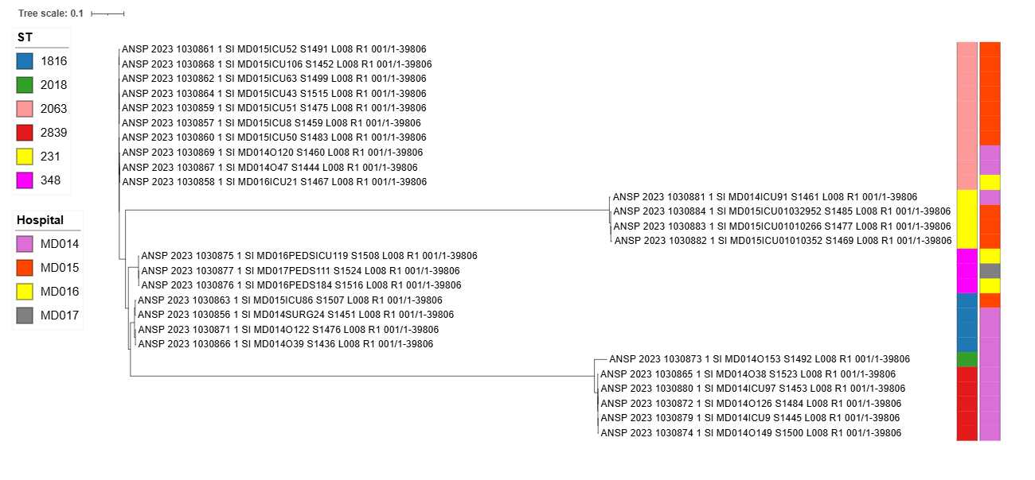
Figure 7. Phylogenetic tree of A. baumannii strains based on SNP analysis and assembled according to MLST profiles (MLST, iTOL).
All sequenced and analyzed A. baumannii isolates were grouped into six clusters according to their sequence types, with each cluster containing between one and ten isolates. MLST phylogenetic analysis showed that sequence type ST2063 was the most common, identified in ten isolates from clinical samples, followed by ST2839 in five isolates, and ST231 and ST1816, each found in four isolates.
It was observed that the first isolates of A. baumannii ST2063 and A. baumannii ST2839 initially appeared in two medical institutions: MD015A and MD014A. By the end of the study, analysis of the phylogenetic tree revealed that A. baumannii belonging to the six STs had been isolated from four medical institutions: MD014A – 8 strains (ST2839 – 5 strains, ST1816 – 4 strains, ST2018 – 1 strain, ST231 – 1 strain, ST2063 – 2 strains), MD015A – 11 strains (ST2063 – 7 strains, ST231 – 3 strains, ST1816 – 1 strain), MD016A – 3 strains (ST348 – 2 strains, ST2063 – 1 strain), MD017A – 1 strain, A. baumannii ST348.
4.2. Development of a standardized algorithm for detecting antimicrobial resistance mechanisms
Evaluating the accuracy of the tests used to identify ESBLs and carbapenemases — based on their sensitivity and specificity — helped identify the most reliable methods. These findings were included in the algorithm developed based on the results (Figure 8), who will guide clinicians in making informed treatment decisions.

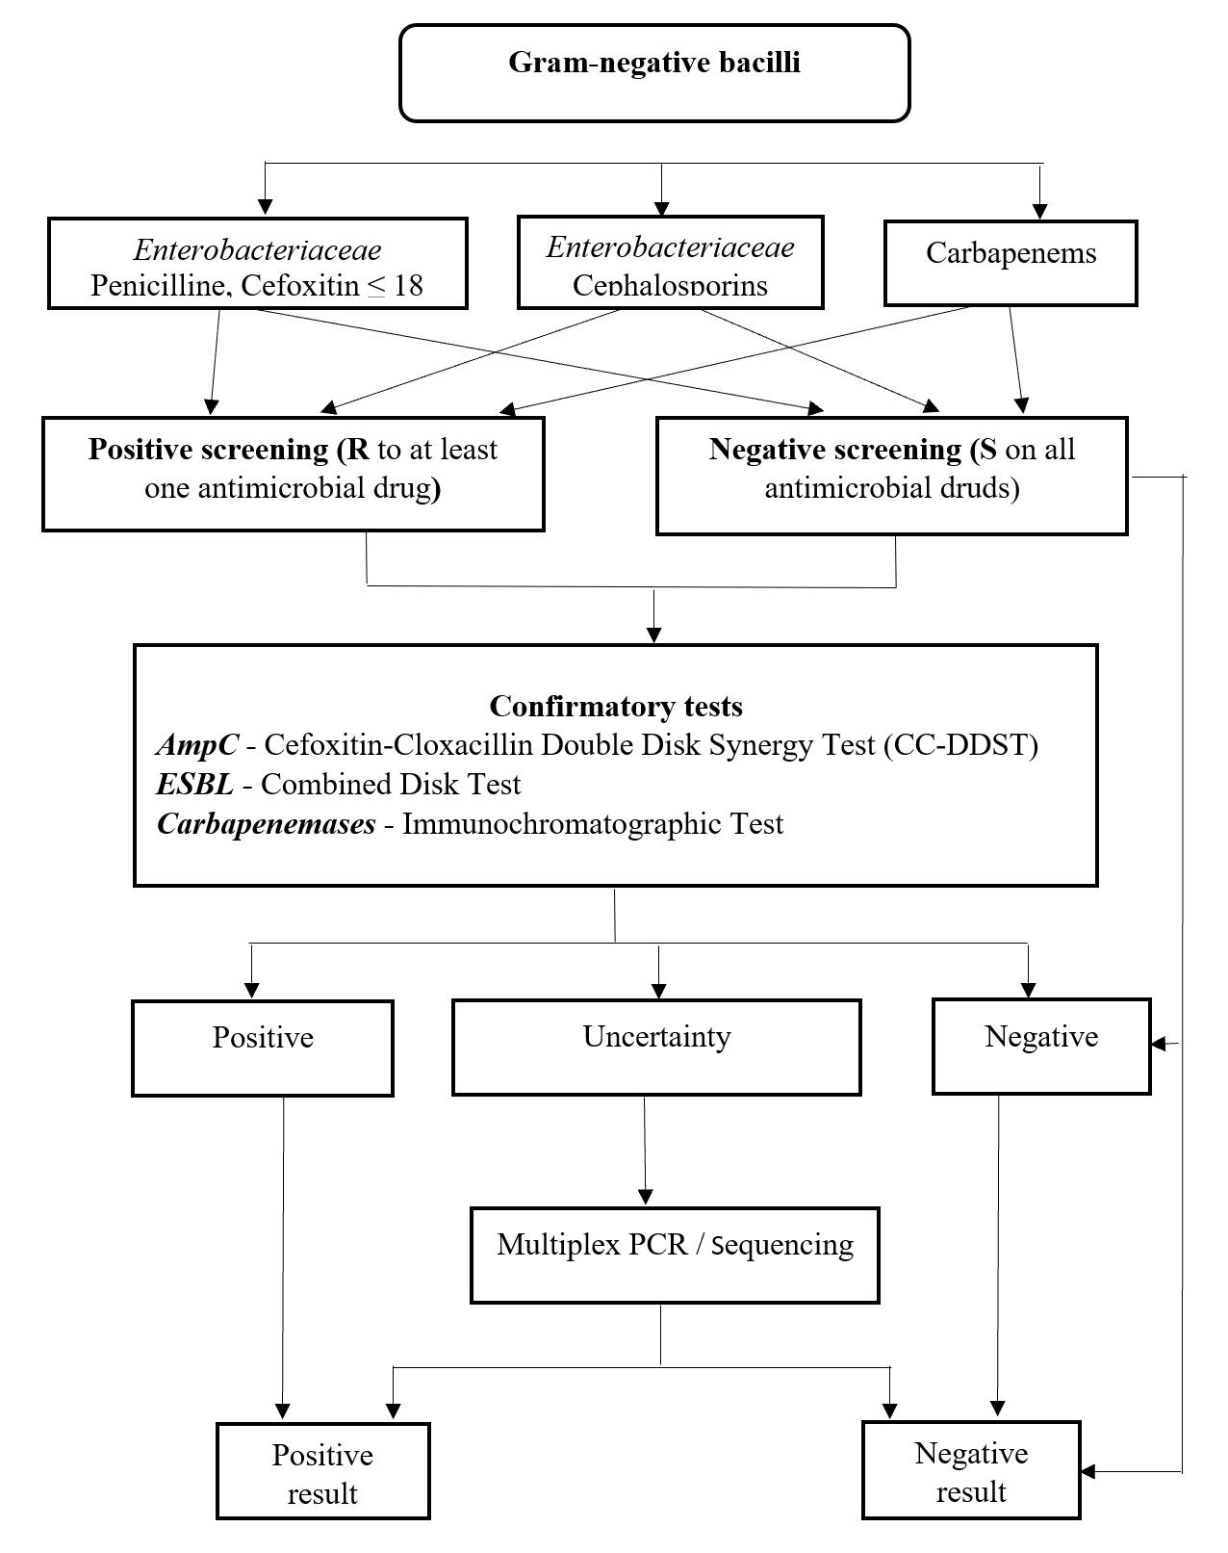
Figure 8. Algorithm for detecting antimicrobial resistance mechanisms in GNB
For detecting ESBL, the combined disc test showed the highest sensitivity and specificity among the three phenotypic methods used.
This test also offers the advantage of being able to process many strains at once, while remaining easy to use and cost-effective. However, the main downside is the longer time needed to get the results.
Of the screening tests evaluated for carbapenemase-producing strains, the immunochromatographic RESIST-5 OKNVI test stood out for its excellent sensitivity and specificity. It also delivers results quickly—often within ten minutes—and, as a commercial test, it is reasonably priced and accessible.
Although PCR is considered the gold standard for detecting AMR, its widespread use in microbiology labs across the country is limited. The technique requires costly equipment and reagents, as well as highly trained, specialized staff, which restricts its broader implementation.

GENERAL CONCLUSIONS
- The assessment of resistance patterns in the 3,047 GNB strains studied revealed high to very high levels of resistance to commonly used antimicrobials. A. baumannii was multidrug-resistant in 99.1% of cases (95% CI: 96.3–100), including 88.4% (95% CI: 85.6–93.9) resistant to carbapenems, and over 90% resistant to other antimicrobial classes. P. aeruginosa showed carbapenem resistance in 70.4% (95% CI: 63.6–79.5) of isolates. K. pneumoniae proved to be rsistant to cephalosporins in 93.9% (95% CI: 85.6–93.9) and to penicillins in 88.6% (95% CI: 85.9–94.2) of strains. Isolates from blood and cerebrospinal fluid exhibited significantly higher resistance levels compared to those from urine, especially among patients admitted in intensive care and surgical units, compared to other hospital units.
- Among the 3,047 GNB strains studied, at least one antimicrobial resistance mechanism was identified in 87.2% (95% CI, 81.4–92.8). ESBL production was confirmed in 90.3% (95% CI, 88.0–92.0) of E. coli isolates, while carbapenemase production was most commonly found in K. pneumoniae at 96.9% (95% CI, 95.0–98.0). The dominant enzyme in both species was OXA-48. P. aeruginosa strains most frequently produced the NDM beta-lactamase, whereas A. baumannii predominantly produced OXA-23. Strains of K. pneumoniae and P. aeruginosa that produced 2 or three 3 of carbapenemases showed significantly higher resistance.
- Analysis of the phylogenetic trees of sequenced strains revealed the main clusters and the most common sequence types circulating in the country: ST131 accounted for 47.1% of E. coli strains, ST395 for 56.6% of K. pneumoniae, ST2063 for 37.0% of A. baumannii, and ST235 for 16.7% of P. aeruginosa. The spread of resistance was initially detected with eight strains of these sequence types in four medical institutions, which expanded over three years to 26 strains across various wards in 14 healthcare facilities nationwide.
- The assessment of phenotypic tests for detecting resistance mechanisms revealed that the combined disc test had the highest sensitivity and specificity for ESBL detection (99.0% and 98.9%, respectively), with no statistically significant difference compared to other tests performed (p > 0.001). For carbapenemase detection, the immunochromatographic method showed a sensitivity of 86.2% and specificity of 91.7%, which was significantly better than the other methods used (p < 0.001).
- By comparing these phenotypic methods to molecular biology techniques (PCR, sequencing) as the gold standard, a standardized algorithm was developed to select the most effective methods based on cost-efficiency, time, and the resources available in laboratories across the country.
- Monitoring the GNB resistance profiles associated to infectious diseases is crucial for tracking the spread of AMR and identifying new treatment options. It also underlines the implementation of national strategies to curb this issue, highlighting the urgent need for a comprehensive and effective system of monitoring and control.

RECOMMENDATIONS
- To encourage close collaboration between clinicians and laboratory experts to select appropriate tests and accurately interpret results, ensuring effective guidance for antimicrobial treatment.
- Tp regularly update and adapt national clinical guidelines and protocols, while improving strategies to control AMR.
- To implement the newly developed algorithm for detecting resistance mechanisms in GNB, based on research findings, to enhance the quality and reliability of AMR surveillance data.
- To closely monitor hypervirulent strains and investigate healthcare-associated infection outbreaks to identify sources and prevent their spread within medical facilities.
- To implement antimicrobial stewardship programs across all healthcare institutions nationwide.
- To use the research findings to reinforce the National Program for AMR Surveillance and Control (2019–2028), including systematic evaluation of key progress indicators.

SUGGESTIONS FOR FUTURE RESEARCH
      - To investigate genetic factors driving healthcare-associated infections using microbiological methods.
- To analyze the economic impact of antimicrobial-resistant GNB infections in Moldova and future outlook.
- To conduct whole-genome sequencing and phylogenetic studies of GNB (such as Salmonella spp. and E. coli) involved in acute diarrheal diseases and outbreak dynamics.
- To assess antimicrobial use in healthcare settings and its correlation with the emergence of resistance mechanisms in circulating microbes.
- To evaluate antimicrobial consumption in medical institutions in relation to the rise of multidrug-resistant organisms.
- To identify microbial virulence factors and forecast the evolution of antimicrobial resistance.
SELECTIVE BIBLIOGRAPHY
- Naghavi M, Vollset SE, Ikuta KS. Global burden of bacterial antimicrobial resistance 1990–2021: a systematic analysis with forecasts to 2050. Lancet. 2024;404(10459):1199-1226. doi:10.1016/S0140-6736(24)01867-1.
- Dunachie SJ, Day NP, Dolecek C. The challenges of estimating the human global burden of disease of antimicrobial resistant bacteria. Curr Opin Microbiol. 2020;57:95-101. doi: 10.1016/j.mib.2020.09.013.
- Anton (Bivol) M, Pantea L, Burduniuc (Popa) O, et al. Evaluation of costs related to antimicrobial resistance of priority Gram-negative bacilli. One Health Risk Manag. 2024;5(1):43-50. doi:10.38045/ohrm.2024.1.06.
- Bassetti M, Kanj SS, Kiratisin P, et al. Early appropriate diagnostics and treatment of MDR Gram-negative infections. JAC Antimicrob Resist. 2022;4(5):dlac089. doi:10.1093/jacamr/dlac089.
- World Health Organization. Antimicrobial resistance. 2021. Disponibil la: https://www.who.int/newsroom/fact-sheets/detail/antimicrobial-resistance
- Masia MD, Dettori M. Antimicrobial Resistance, Healthcare-Associated Infections, and Environmental Microbial Contamination. Healthcare (Basel). 2022;10(2):242. doi:10.3390/healthcare10020242.
- Pantea L, Croitoru C, Burduniuc (Popa) O. Impactul economic al rezistenței antimicrobiene în perspectiva abordării One Health. În: Știință, educație, cultură. 2023; 1:75-80. ISBN: 978-9975-83-254-0.
- Pantea L, Croitoru C, Burduniuc O, Balan G, Anton M. Features of the economic impact of antimicrobial resistance elucidated in scientific publications. Arta Medica. 2023;4(89):35-45. https://doi.org/10.5281/zenodo.10429356.
- Hormozi SF, Vasei N, Aminianfar M, et al. Antibiotic resistance in patients suffering from nosocomial infections in Besat Hospital. Eur J Transl Myol. 2018;28(3):7594.
- Moraru A, Pântea V, Cebotarescu V, et al. Rezistenţa antimicrobiană la pacienţii internaţi în Spitalul Clinic de Boli Infecţioase „Toma Ciorbă” (anii 2011–2015). Obshchestvennoe Zdorov’e Ekonomika i Menedzhment v Meditsine. 2017;3(73):25-27. ISSN 1729-8687.
- World Health Organization. Global antimicrobial resistance and use surveillance system (GLASS) report. 2022 Dec 9. Disponibil la: https://www.who.int/publications/i/item/9789240062702
- World Health Organization. Assessing non-prescription and inappropriate use of antibiotics: report on survey. Copenhagen: WHO Regional Office for Europe; 2019. Disponibil la: http://www.euro.who.int/en/publications/abstracts/assessing-non-prescription-and-inappropriate-use-of-antibiotics-2019
- World Health Organization. Molecular methods for antimicrobial resistance (AMR) diagnostics to enhance the Global Antimicrobial Resistance Surveillance System. Geneva: WHO; 2019. (WHO/WSI/AMR/2019.1). https://www.who.int/publications/i/item/WHO-WSI-AMR-2019.1
- European Centre for Disease Prevention and Control (ECDC). Antimicrobial resistance surveillance in Europe 2023–2021. 2023. Disponibil la: https://www.ecdc.europa.eu/en/publications-data/antimicrobial-resistance-surveillance-europe-2023-2021-data
- European Centre for Disease Prevention and Control (ECDC). Surveillance Atlas of Infectious Diseases. 2023. Disponibil la: https://www.ecdc.europa.eu/en/surveillance-atlas-infectious-diseases.
- Bucov V, Burduniuc O, Balan G, Grumeza M, Craciun O, Anton (Bivol) M. Rezistența la antimicrobiene. Caracteristica rezistenței la preparate antimicrobiene a bacteriilor gram-negative. Sănătate Publică Economie și Management în Medicină. 2021;1(89):50-56. ISSN 1729-8687.
- Ungureanu V. Rezistența la antibiotice – mecanisme, cauze și măsuri de prevenire și combatere. Medic.ro. 2024. doi:10.26416/Med.160.4.2024.10042.
- World Health Organization. Antimicrobial resistance: fact sheet. Disponibil la: https://www.who.int/news-room/fact-sheets/detail/antimicrobial-resistance
- Anton M, Burduniuc A, Croitoru C, Behta E, Balan G. Rezistența la antimicrobiene a E. coli și K. pneumoniae izolate de la pacienți cu infecții ale tractului urinar. Sănătate Publică Economie și Management în Medicină. 2023;4(97):145-149. doi:10.52556/2587-3873.2023.4(97).25.
- Anton M, Tapu L, Balan G, et al. Evaluarea pattern-urilor de rezistență a bacililor gram-negativi prioritari izolați din biosubstrate clinice. Arta Medica. 2023;89(4):67-71. DOI: https://doi.org/10.5281/zenodo.10429464.
- Anton (Bivol) M, Țapu L, Burac O, Lozneanu I, Burduniuc (Popa) O. Antimicrobial resistance of Gram-negative bacilli isolated from invasive infections. Rev Științ Sănătate Moldova. 2022;1(29):126. ISSN 2345-1467.
- Balan G, Sofronie O, Rusu IF, Tapu L, Burduniuc (Popa) O. Mecanisme de rezistență la antimicrobiene caracteristice bacililor gram-negativi de importanță clinică. Akademos. 2022;4(67):34-42. doi:10.52673/18570461.22.4-67.04.
- Anton M. Genetic bases of antimicrobial-resistant Gram-negative bacteria isolated from invasive infections in the Republic of Moldova. One Health Risk Manag. Chișinău; 2024; 5(2):34-41.https://doi.org/10.38045/ohrm.2024.2.04.
- Behta E, Burduniuc O, Bucova V, Crăciun O, Anton (Bivol) M, et al. Antimicrobial discovery – impact of natural sources. Stud Univ Moldav Ser Științe Reale ale Naturii. 2020;4(131):263-278. ISSN 1814-3237; ISSN online 1857.
- Garnacho-Montero J, Amaya-Villar R. The problem of multidrug resistance in Gram-negative bacilli in intensive care units: treatment and prevention strategies. Med Intensiva (Engl Ed). 2022;46(6):326-335. doi:10.1016/j.medine.2022.04.006.
- European Centre for Disease Prevention and Control. ECDC study protocol for genomic-based surveillance of carbapenem-resistant and/or colistin-resistant Enterobacteriaceae at the EU level. Version 2.0 Stockholm: ECDC; 2018.

ȘTIINȚIFICE LIST OF PUBLICATIONS AND CONTRIBUTIONS TO SCIENTIFIC FORUMS

- articles in international peer-reviewed journals:
- articles published in ISI, SCOPUS, and other international databases*
- Revenco N., Bujor D., Balanuta A.M., Horodisteanu-Banuh A., Cirstea O., Holban A., Rotari A., Burduniuc O., Anton M. Bacterial agents associated with acute lower respiratory infections in children under five years of age in the Republic of Moldova. In: Archives of the Balkan Medical Union, december 2023, no. 4, vol. 58, pp. 335-340. ISSN 1584-9244. (IF:1,9) https://doi.org/10.31688/ABMU.2023.58.4.04
- Anton (Bivol) M., Pantea L., Burduniuc (Popa) O., Chilianu M., Bucov V., Tapu L. Evaluation of costs related to antimicrobial resistance of priority Gramnegative bacilli. In: One Health and Risk Management, 2024, vol. 5, nr. 1, pp. 43-50. ISSN 2587-3458. DOI: https://doi.org/10.38045/ohrm.2024.1.06
- Anton M. The genetic basis of gram-negative bacteria resistant to antimicrobials isolated from invasive infections in the Republic of Moldova. In: One Health & Risk Management, 2024, 5(2), pp. 34-41. https://doi.org/10.38045/ohrm.2024.2.04
- articles in peer-reviewed international journals
- Anton M. The perspectives of whole genome sequencing in strengthening the outbreak investigations and public health surveillance. In: Romanian Archives of Microbiology and Immunology (RoAMI), 2023, vol 82(1), pp. 25-34. Category B+. ISSN 2601-9418. DOI: 10.54044/rami.2023.01.04
- Articles in accredited national scientific journals:
- Category B journals
- Behta E., Burduniuc (Popa) O., Bucov V., Craciun O., Bivol M., Burduniuc A., Brînza O., Grumeza M., Balan G. Antimicrobial discovery – impact of the natural sources. In: Studia Universitatis Moldaviae (Seria Ştiinţe Reale şi ale Naturii), 2020, nr. 6(136), pp. 39-48. ISSN 1814-3237. DOI: https://doi.org/10.5281/zenodo.4431529
- Bucov, V.; Burduniuc, O.; Balan, G.; Grumeza, M.; Craciun O.; Bivol, M. Rezistența la antimicrobiene. Caracteristica rezistenței la preparate antimicrobiene a bacteriilor gram-negative. În: Sănătate Publică Economie și Management în Medicină. Chișinău. 2021, 1 (88), 50-56. ISSN 1729-8687. https://doi.org/10.52556/2587-3873.2021.1(88).06
- Anton M., Burduniuc A., Croitoru C., Behta E., Balan G. Rezistența la antimicrobiene a E. coli și K. pneumoniae izolate de la pacienții cu infecții ale tractului urinar. In: Sănătate Publică, Economie şi Management în Medicină , 2023, nr. 4(97_S), pp. 145-149. ISSN 1729-8687. DOI: https://doi.org/10.52556/2587-3873.2023.4(97).25
- Anton M., Tapu L., Balan G., Bucov, V., Burduniuc (Popa) O., Lozneanu I., Perjeru M., Colac S. Evaluarea pattern-urilor de rezistență a bacililor gram-negativi prioritari izolați din biosubstrate clinice. In: Arta Medica, 2023, nr. 4(89), pp. 67-71. ISSN 1810-1852. DOI: https://doi.org/10.5281/zenodo.10429464
- Pantea L., Croitoru C., Burduniuc O., Balan G., Anton M. Features of the economic impact of antimicrobial resistance elucidated in scientific publications. In: Arta Medica , 2023, nr. 4(89), pp. 35-45. ISSN 1810-1852. DOI: https://doi.org/10.5281/zenodo.10429356
- Anton M., Iaconi O.S., Perjeru M., Ceban V., Beleacov E., Burduniuc O. Knowledge, attitudes and behaviors of the population of Chisinau municipality regarding the use of antibiotics. In: Mold J Health Sci. 2025;12(1):35-40. https://doi.org/10.52645/MJHS.2025.1.06
- Burduniuc (Popa) O., Lupu M., Bucov V., Tapu L., Anton (Bivol) M., Colac S. Secvențierea metagenomică în diagnosticul rezistenței la antimicrobiene. In: Revista de Ştiinţă, Inovare, Cultură şi Artă „Akademos”, 2024, nr. 2(73), pp. 84-90. ISSN 1857-0461. DOI: 10.52673/18570461.24.2-73.08
- Articles in conference proceedings:
- international conferences held in the Republic of Moldova
- Tapu L., Colac S., Anton (Bivol) M., Lupu M., Burduniuc (Popa) Bucov V. Unele aspecte de utilizare a tehnologiilor metagenomice: diagnosticul infecțiilor și supravegherea rezistenței la antimicrobiene. În: Patrimoniul cultural de ieri – implicaţii în dezvoltarea societăţii durabile de mâine. Supliment al revistei științifice „Authentication and Conservation of Cultural Heritage. Research and Technique”, Volumul 8, Iași-Chișinău-Lviv, 19-20 septembrie 2024, pp. 565 – 569. ISSN 2558-894X.
- Abstracts/summaries in proceedings of international scientific conferences:
- Anton M. Analiza filogenetică a tulpinilor de Escherichia coli și Klebsiella pneumoniae izolate din sânge. În: Patrimoniul cultural de ieri – implicaţii în dezvoltarea societăţii durabile de mâine. Supliment al revistei științifice „Authentication and Conservation of Cultural Heritage. Research and Technique”, Chişinău. Iași-Chișinău-Lviv: 11-12 februarie 2025, Ediția 11, p. 364. ISSN 2558 – 894X.
- Anton M. Evaluarea rezistenței Pseudomonas aeruginosa și Acinetobacter baumannii la diferite clase de antibiotice în ultimii 10 ani. În: Patrimoniul cultural de ieri – implicaţii în dezvoltarea societăţii durabile de mâine. Supliment al revistei științifice „Authentication and Conservation of Cultural Heritage. Research and Technique”, Chişinău. Iași-Chișinău-Lviv: 11-12 februarie 2025, Ediția 11, p. 470. ISSN 2558 – 894X.
- Abstracts/ summaries in proceedings of national scientific conferences with international participation
- Burduniuc O., Bivol M., Brinza O., Craciun O., Balan G. Emergence of carbapenem-resistant enterobacteriaceae: overview of a major public health challenge. One Health & Risk Management (Materials of the National Scientific Conference with international participation „One health” approach in a changing world), 2021, 2(4S), p. 29. Available at: https://journal.ohrm.bba.md/index.php/journal-ohrm-bba-md/article/view/193
- Anton M., Mihalachi N., Burduniuc O. Analysis of antimicrobial resistance in clinical strains of Klebsiella pneumoniae, In: One Health & Risk Management (Materialele Conferinței Naționale cu participare internațională „O singură sănătate – realizări și provocări”), 2023, nr.2(S_Rez), supl. nr. 1, p. 12. Available at: https://journal.ohrm.bba.md/index.php/journal-ohrm-bba-md/article/view/591
- Anton M., Burduniuc O., Neronova N., Balan G. Antimicrobial resistance analysis of clinical Escherichia coli. One Health & Risk Management (Materialele Conferinței Naționale cu participare internațională „O singură sănătate – realizări și provocări”), 2023, p. 49. Available at: https://journal.ohrm.bba.md/index.php/journal-ohrm-bba-md/article/view/503
- Grumeza M., Anton M., Burduniuc A. The role of the microbiological laboratory in diagnosing the resistance of microorganisms to antimicrobials: literature review. In: One Health and Risk Management (Materialele Conferinței Naționale cu participare internațională „Abordarea O singură sănătate – realizări și provocări”) 2023, nr. 2(S_Rez), supl. nr. 1, p. 16. ISSN 2587-3458. https://ibn.idsi.md/ro/vizualizare_articol/191974 7.4.
- Abstracts/summaries in proceedings of national scientific conferences
- Anton (Bivol) M., Tapu L., Burac O., Lozneanu I., Burduniuc O. Antimicrobial resistance of gram-negative bacilli isolated from invasive infections. In: Revista de Ştiinţe ale Sănătăţii din Moldova (Culegere de rezumate ale Conferinței Științifice Anuale „Cercetarea în biomedicină și sănătate: Calitate, excelență și performanță”), 2022, nr. 3 An.1(29), p. 126. ISSN 2345-1467. https://ibn.idsi.md/vizualizare_articol/168324
- Anton M., Mihalachi N., Bălan G. Caracterizarea genetică a tulpinilor de Acinetobacter baumannii multirezistente la antimicrobiene. În: One Health and Risk Management (Materialele Conferinței Științifico-practice Naționale „Fiecare doză de vaccin contează”), Ediție specială, 2023, nr. 1(S), p.58. ISSN 2587-3458. https://ibn.idsi.md/ro/vizualizare_articol/183534/datacite
- Bunescu I., Holban T, Burduniuc O, Anton M., Sinițîna I. Clinical- evolutionary and diagnostic particularities in septicemia. În: Moldovan Journal of Health Sciences, Culegere de rezumate ale Conferinței Științifice Anuale „Cercetarea în biomedicină și sănătate: Calitate, excelență și performanță”, 19-21 octombrie 2022, Anexa 1, p.130, ISSN 2345-1467. Disponibil la https://repository.usmf.md/handle/20.500.12710/24579

- Active participation with presentations and posters at scientific events:
- International
- Anton M. Analiza filogenetică a tulpinilor de Escherichia coli și Klebsiella pneumoniae izolate din sânge. Conferința științifică internațională „Patrimoniul cultural de ieri – implicaţii în dezvoltarea societăţii durabile de mâine”. Iași-Chișinău-Lviv, Chișinău 11-12 februarie 2025 (sectiunea 14, pag. 25)
- Anton M., Perjeru M., Lozneanu I., Țapu L., Croitoru C., Bălan G., Burduniuc O. Method for raising the degree of awareness in children about the prevention of antimicrobial resistance. International exhibition of innovation and technology transfer EXCELLENT IDEA – 2nd edition. Chisinau, 18 septembrie 2023.
- National
- Anton M. Rezistenţa la antimicrobiene a bacililor Gram negativi izolați din infecții invazive. Conferința științifică anuală „Cercetarea în biomedicină și sănătate: calitate, excelență și performanță. Chișinău, 19-21 octombrie 2022.
- Anton M. Antimicrobiene: clasificare, mecanisme de acțiune. Rezistența microorganismelor la antimicrobiene (RAM). Workshop medical: Programele de stewardship antimicrobian – elemente esențiale în prevenirea rezistenței la antimicrobiene, Conferința științifică anuală „Cercetarea în biomedicină și sănătate: calitate, excelență și performanță. Chișinău 19-21 octombrie 2022.
- Anton M. Analiza rezistenței antimicrobiene a tulpinilor clinice de Escherichia coli. Săptămâna medicală balcanică, ediția a XXXVII-a „Perspective ale medicinei balcanice în era post COVID-19”. Chișinău 7-9 iunie 2023.
- Anton M. Importanța testării microbiologică a hemoculturilor. Infecțiile invazive cu bacili gramnegativi rezistenți la antimicrobiene. Conferința națională cu participare internațională „Actualități în pediatrie și impactul imunizării asupra morbidității și mortalității copiilor în Republica Moldova. Chișinău, 22-23 septembrie 2023.
- Anton M. Analiza rezistenței patogenilor gram-negativi non-fermentativi de importanță clinică. Conferința științifică anuală „Cercetare în biomedicină și Sănătate: Calitate, excelență și performanță”. Chișinău, 18-20 octombrie 2023.
- Anton M. Sistemul de Supraveghere Epidemiologică a rezistenței microorganismelor la antimicrobiene în Republica Moldova. Conferința națională cu participare internațională „Abordarea O Singură Sănătate – realizări și provocări”. Chișinău, 23-24 noiembrie 2023.
- Anton M. Analysis of antimicrobial resistance in clinical strains of Klebsiella pneumoniae. Conferința națională cu participare internațională „Abordarea O Singură Sănătate – realizări și provocări”. Chișinău, 23-24 noiembrie 2023.
- Anton M. Sistemul de supraveghere epidemiologică a rezistenței microorganismelor la antimicrobiene în Republica Moldova. Conferința națională „Sănătatea și fenomenul rezistenței la antimicrobiene în țările cu venituri mici și medii din Europa de Est”. Chisinău, 27 ianuarie 2024.
- Anton M., Perșeru M., Lozneanu I., Colac S. Metodă de creștere a gradului de conștientizare la copii cu privire la prevenirea rezistentei la antimicrobiene. Nopatea tinerilor cercetători. Chișinău, 29 septembrie 2023.

ADNOTARE
La tema tezei de doctor în științe medicale a doctorandei Anton Maria: „Rezistența la beta-lactamine a bacililor Gram-negativi izolați din biosubstrate clinice”.
Specialitatea 313.02 – Microbiologie, virusologie medicală.
Actualiatate. Rezistența BGN la antimicrobiene reprezintă una dintre cele mai stringente probleme de sănătate publică la nivel global. În ultimele două decenii, patogenii E. coli, K. pneumoniae, P. aeruginosa și A. baumannii au dezvoltat mecanisme complexe de rezistență, incluzând producerea de beta-lactamaze cu spectru extins (ESBL) și carbapenemaze.
Scopul lucrării: Evaluarea profilurilor de rezistență la β-lactamine și stabilirea grupurilor filogenetice ale BGN prioritari cu elaborarea algoritmului metodologic standardizat de detectare a mecanismelor de rezistență.
Obiectivele lucrării: determinarea profilurilor de rezistență la antimicrobiene ale BGN izolați din diferite biosubstraturi clinice; caracterizarea moleculară a BLSE și a carbapenemazelor aferente BGN; analiza comparativă a diferitor tehnici microbiologice de identificare a BGN rezistenți la beta-lactamine cu dezvoltarea unui algoritm metodologic standardizat; propunerea de măsuri eficiente de prevenire și control a infecțiilor cauzate de BGN multirezistenți.
Noutatea şi originalitatea ştiinţifică: S-a realizat un studiu complex prin utilizarea motodelor de biologie moleculară, care a permis aprecierea şi evaluarea poziţiei BGN circulanți pe teritoriul țării în arborii filogenetici globali, lucru important pentru argumentarea tendinței evolutive a rezistenței BGN și argumentarea terapiei empirice la pacienții cu astfel de infecții.
Rezultatele obținute au stat la baza elaborarării unui algoritm standardizat care urmează a fi implelentat în laboratoarele microbiologice din cadrul retelei de supraveghere a RAM.
Rezultate obținute: a fost identificat spectrul microbiologic și diversitatea genotipică a BGN prioritari, inclusiv prevalența tulpinilor de BGN producătoare de BLSE și de carbapenemaze; spectrul de enzime la BGN; tipul de secvență predominant pe teritoriul țării. A fost elaborat un algoritm standardizat de determinare a markerilor rezistenței și propuse de măsuri îmbunătățire pentru supravegherea și controlul RAM bazate pe dovezi
Semnificaţia teoretică: Studiul realizat va aduce un aport semnificativ la actualizarea și metodologiei de determinare a mecanismelor de rezistență la preparatele antimicrobiene.
Valoarea aplicativă: Rezultatele au fost incluse în programele de învățământ pentru studenţi, rezidenţi şi medici. De asemenea au fost elaborate materiale utile, inclusiv ghiduri pentru îndrumarea medicilor în activitatea profesională şi pliante informative pentru conștientizarea populaţiei despre problema RAM.
Implementarea rezultatelor științifice: elaborarea algoritmului de determinare a mecanismelor de rezistență la antimicrobiene ale BGN; elaborarea a 3 ghiduri pentru personal medical și implementarea lor in diferite instituții medicale și o indicație metodică inclusă în programul de instruire pentru studenți, rezidenți și în cadrul cursurilor de specializare.
Structura tezei: introducere, patru capitole, concluzii generale şi recomandări, bibliografie (165) titluri, 9 anexe, 65 pagini de text de bază, 14 tabele şi 31 figuri. Rezultatele sunt publicate în 28 lucrări științifice.
Cuvinte-cheie: bacili Gram-negativi, rezistența la antimicrobiene, mecanisme de rezistență, beta-lactamaze cu spectru extins, carbapenemaze.

ANNOTATION
For the doctoral thesis in medical sciences of the PhD candidate Anton Maria: “Beta-actam Resistance of Gram-negative Bacilli Isolated from Clinical Biosubstrates.”
Specialty 313.02 – Microbiology, Medical Virology.
Relevance. Antimicrobial resistance among Gram-negative bacilli (GNB) is one of the most pressing global public health challenges. Over the past two decades, pathogens such as E. coli, K. pneumoniae, P. aeruginosa, and A. baumannii have developed complex resistance mechanisms, including the production of extended-spectrum beta-lactamases (ESBLs) and carbapenemases.
Aim: To evaluate the β-lactam resistance profiles and establish the phylogenetic groups of priority GNB, with the development of a standardized methodological algorithm for detecting resistance mechanisms.
Objectives: determination of antimicrobial resistance profiles of GNB isolated from various clinical biosubstrates; molecular characterization of ESBLs and carbapenemases in GNB; comparative analysis of different microbiological techniques used to identify beta-lactam–resistant GNB and development of a standardized methodological algorithm; proposal of effective measures for the prevention and control of infections caused by multidrug-resistant GNB.
Scientific novelty and originality: A comprehensive study was carried out using molecular biology methods, allowing the assessment and positioning of circulating GNB in the country within global phylogenetic trees—an important aspect for understanding the evolutionary trends of GNB resistance and justifying empirical therapy in patients with such infections.
The obtained results formed the basis for developing a standardized algorithm to be implemented in microbiology laboratories within the national AMR surveillance network.
Results obtained: The microbiological spectrum and genotypic diversity of priority GNB were identified, including the prevalence of ESBL- and carbapenemase-producing strains; the spectrum of resistance enzymes; and the predominant sequence type circulating in the country. A standardized algorithm for determining resistance markers was developed, and evidence-based improvements for AMR surveillance and control were proposed.
Theoretical significance: The study provides a significant contribution to updating and improving the methodology for determining antimicrobial resistance mechanisms.
Practical value: The results have been included in educational programs for students, residents, and physicians. Useful materials were developed, including guidelines for assisting healthcare professionals in their practice and informational leaflets to raise public awareness about AMR.
Implementation of scientific results: Development of an algorithm for determining antimicrobial resistance mechanisms in GNB; elaboration of three guidelines for healthcare personnel and their implementation in various medical institutions; and preparation of a methodological instruction included in training programs for students, residents, and specialization courses.
Structure of the thesis: Introduction, four chapters, general conclusions and recommendations, bibliography (165 titles), 9 appendices, 65 pages of main text, 14 tables, and 31 figures. The results are published in 28 scientific works.
Keywords: Gram-negative bacilli, antimicrobial resistance, resistance mechanisms, extended-spectrum beta-lactamases, carbapenemases.

